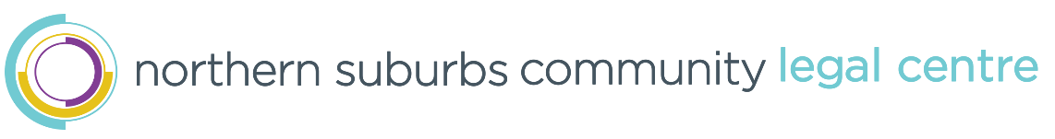
Application for Membership 2024/2025

Submit to Returning Officer via email mark.jones@nsclegal.org.au by Wed 9 Oct 2024.

Title
First Name
Last Name
Organisation
(if applicable)
Mobile/Phone
Email

Confirmation of Application
I make application to become a member of the Northern Suburbs Community Legal Centre (NSCLC) Inc and agree to support the vision, mission and values of the organisation.

I understand that if I am nominated/elected as a Board Member for NSCLC I must provide an appropriate Australian Police Check and/or Criminal Check.

Signature
Date

Membership Type and Fee Amount
Student/ Concession ☐ | Individual ☐ | Organisation ☐ | Government ☐ | Life Member ☐
$5.00 | $10.00 | $20.00 | $30.00 | $10.00

For further information:

Returning Officer
Northern Suburbs Community Legal Centre
PO Box 793
Mirrabooka WA 6941
Email: mark.jones@nsclegal.org.au
Telephone: (08) 9440 1663
Returning Officer Use Only
Date Received
Membership No.
Fee Fully Paid
Agenda Item

